Add a Staff Member

Functionality: This dialogue allows the user to add a Staff Member to the Main Org. It allows the user to capture all information necessary for billing, contacting and tracking and in the future to handle HR functions. The Add-a-Staff Member dialogue, in Physia, handles the majority of this. First a review of fields will be discussed and then the action codes will be discussed.

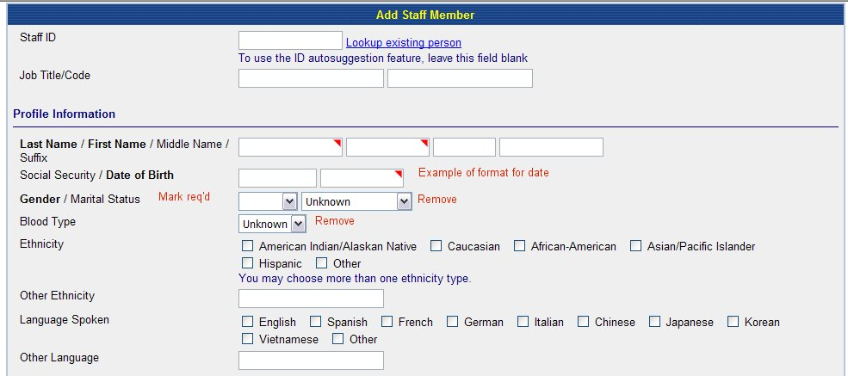
Fig 1a

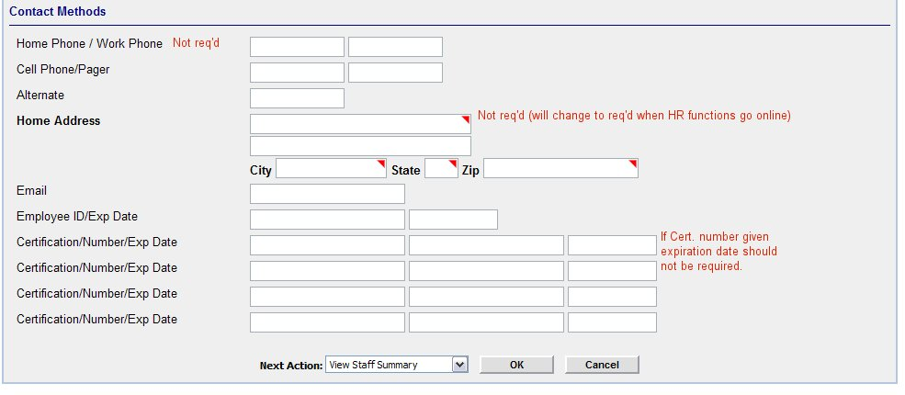
Fig 1b

Add:
- Look up for existing person. Either an icon, like the magnifying glass in Physia, or hyperlink on the word, as shown here, but it should be consistent for each Add-a-Person dialogue. (Fig 1a)
- Example for date format. (Fig 1a)
- Facility ID. This should include all orgs added from Department or Facility org types. ***Note: Whatever format is used, it should be consistent throughout the application***
- In Medspective, be sure to identify the fields for Name (Last Name/First Name/Middle) ***Note: Whatever format is used, it should be consistent throughout the application*** Fig 1a
- In Medspective, markers indicating required fields (In Physia, it is a red triangle). The following should be required: Name, Date of Birth, Gender (Fig 1a)
- Add Next Action to bottom of screen, next to Save/Cancel. (More detail given in action codes’ section)

Remove:
- Blood type.
- Marital Status
- In Medspective, remove Death field.

Edit:
- If possible, when user chooses “other” for ethnicity and/or language, the application offers a free text field.
- In Medspective “System Login” changed to Staff ID *** Note: all add –a-person dialogue should either say [person type] ID or just “Person ID”. If a person can be multiple person types then maybe it should be called Person ID—any thoughts?

Action Codes

Look up at Staff ID

Look up an existing person: This lookup, whether an icon (magnifying glass or the words are a hyperlink) should take user to a search dialogue which allows the user to search for a person—see below. ***Note the method chosen for lookup should stay consistent throughout the application. **

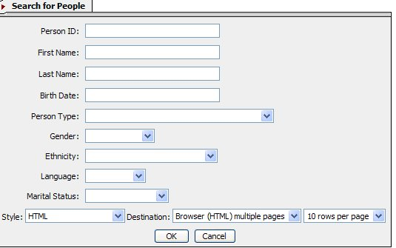

Fig 2a
This is a good search engine, because it is a search engine for all persons.

Add

- If birth date has to be in a certain format, then to the left of the Birth date box, should be a message stating the format (mmddyyyy). **Note: Anywhere in the application, where information should be entered in a certain format, there should be a small example of it near the field.

Once the user clicks OK, the system should pull up the results. See below. ***Note: Search results include all types of persons.

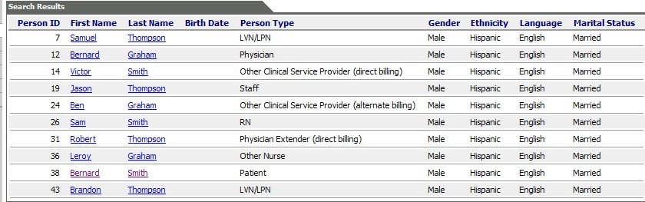
Fig 2b

Edit

- The hyperlink to the patient summary should be on the person ID.
- Switch Last Name column with First Name Column
- Sort in alphabetical order by Last Name.
- If a person is in several Person Types-either all types should be listed under the Person Type column or the person should have a row for each person type. (These will appear beneath each other since the persons will be listed alphabetically.)

Function

a) If a person is found in Org but not for Staff Member Person type, then the user should be able to click the Person ID (the hyperlink) and an additional dialogue should come up:
***If Patient ID hyperlinks to patient summary (as requested above) - can it also function to bring up the above dialogue? If not then can the name be made a hyperlink to summary page and Person ID made to be the link to above dialogue? *****

Do you want to add [Person_id] to Staff Member Type?→Yes→Dialogue for Add-a-Physician comes up with as much information as possible auto filled→User enters any additional information→User chooses Next Action→User clicks [Ok]→Application performs Next Action.
**See further down for descriptions on next action. **
Or

Do you want to add [Person_id] to Staff Member Type?→No→Application takes user back to blank Add-a-Staff Member Dialogue.

- If person is not found in the results of the search, the user should be able to close the search results and the application should take the user back to the blank “Add-a-Staff Member” dialogue.

Warning on Phone number
If work phone number is left blank the application should show a warning (see below, an example from Physia).

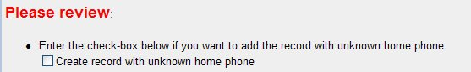

Next Action:

Once the user completes all necessary fields in Add-a-Nurse Dialogue, they should choose a Next Action (see below)

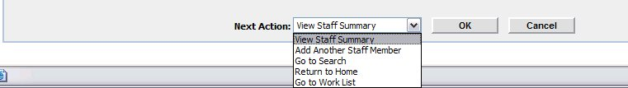

View Staff Summary: Takes user to Staff Summary Page
Add Another Staff Member: Takes user to blank Add-a-Staff Member dialogue
Go to search: Takes a user to a Search People engine
Return to Home: Takes user to their Home Page
Go to Work List: Takes user to a list of Work List

Function:

User Clicks [OK] →Application suggests 3 Person Ids→Application should add an [OK] [Cancel] Button next to suggestions→User chooses Person Id→Clicks [OK]→ Application adds Person and performs Next Action.

